Document: Hydraulic Services Design Brief

Status For Information (20% Documentation)

For the Attention of: Client Company Name
Client Address
Suburb, State, Postcode

Client Contact name

Project Details: Sellick Job Number
Block XX, Section XX, Suburb ACT
Development Name

Prepared
Author: Carl Sommerville

Signature: (Original signed)

Date: 13 August 2021

Reviewed

Reviewer: Brad Williams

Signature: (Original signed)

Date: 13th August 2021

Revision | Date | Description of Revision | Prepared | Reviewed
01 | DD/MM/YYYY | 20% Documentation | CRS | BW

Contents
1.0 STANDARDS AND CODES 3
2.0 GENERAL REQUIREMENTS 3
3.0 SEWER DRAINAGE AND SANITARY PLUMBING 4
4.0 DOMESTIC COLD WATER 6
5.0 DOMESTIC HOT WATER 7
6.0 ROOFING, GUTTERS AND DOWNPIPES 8
7.0 STORMWATER DRAINAGE 8
8.0 FIRE HYDRANT AND FIRE HOSE REEL SYSTEMS 8
9.0 METERING 9
10.0 FIXTURES AND FITTINGS 9

- STANDARDS AND CODES

Design of the hydraulic services shall be in accordance with the following Standards and Codes current at the date of the execution of this Design Brief.
- The Building Code of Australia and all referenced Australian Standards;
- AS 3500 Parts 1 to 4 inclusive ‘The National Plumbing and Drainage Code’;
- The requirements and regulations of the ACT Fire Brigade and any fire engineered design brief (FEDB) prepared by the Contractor and approved by the ACT Fire Brigade;
- The requirements and regulations of the ACT Health;
- The requirements and regulations of Environment ACT;
- The requirements and regulations of ACT Department of Urban Services – Roads and Stormwater Section;
- The requirements and regulations of ACT Health; and
- The requirements and regulations of ICON Water including but not limited to
- Water and Sewerage ACT
- Water and Sewerage Regulations

- GENERAL REQUIREMENTS
The following general requirements are to be met.
- The roof stormwater plumbing and drainage shall be a combination of conventional downpipes and gravity drainage;
- The hydraulic stormwater drainage will connect into the nearest available civil stormwater.
- Subsoil drainage shall be installed behind retaining walls where required and coordinated with the civil design when required;
- A portion of the roof will be captured and conveyed to the onsite rainwater storage tank (sized by the projects Civil Engineer). Captured rainwater is to b used for toilet flushing, external hose cocks for future maintenance, charging the buildings trapped tundishes (where required) and supply to the Mechanical Humidifiers (typically located on the roof).
- The sanitary plumbing and drainage pipework shall be constructed using uPVC with solvent cement joints;
- The tradewaste plumbing and drainage pipework shall be constructed using HDPE with fusion welds where required;
- The domestic cold water supply shall be constructed using copper for the main risers and/or plastic (Rehau or equal) for the branch lines within the wet areas. Copper pipe and fire seal shall be used where penetration of fire walls occurs;
- The domestic hot water supply shall be from point of use or central electric instantaneous hot water heaters using copper for the main flow and/or plastic (Rehau or equal) for the branch lines within the wet areas. Copper pipe and fire seal shall be used where penetration of fire walls occurs;
- The site domestic water supply will come from the existing 150mm-diameter internal water ring main.
- Rain water reuse will reticulate via a booster pump arrangement and inline filtration system, pipe reticulation to the wet areas and Mechanical equipment will be via Rehau (lilac in colour).
- The site sewer will connect to the existing internal 150dia sewer main that discharges into the sites existing Sewer Pump Station;
- All penetrations through the walls and floors shall be fire rated to the same fire rating as the adjacent wall or floor;
- The Hydraulic Contractor is responsible for producing an accurate set of works as executed drawings showing the installed position of all services, equipment, valves and pipework.
- For ACT Projects the Works as executed drawings shall be signed by a Private Plumbing Plan Certifier and the Hydraulics Contractor is responsible for all fees and charges by the Private Plumbing Plan Certifier.
- The project shall be modelled using REVIT and adopting the online share cloud of BIM 360. Level of Detail (LOD) is to be a minimum of LOD300.

- SEWER DRAINAGE AND SANITARY PLUMBING
- The sewer drainage shall include an Disconnector Trap (DT) performing as the buildings overflow relief gully to prevent the surcharge of sewage into the building. The drainage system shall include a combination of two systems;
- An internal condensate drainage system that serves the Fanwall corridors, CRAC units and mechanical air-conditioning units throughout the building and:
- A conventional sanitary drainage system serving the wet areas, staff amenities like lunchrooms.
- The sanitary plumbing and drainage system will be designed for the project so that it can be adequately maintained and serviced;
- All fixtures and fittings shall be part of the Architects specification and of good commercial quality vitreous china or stainless steel. All waste and vent pipes shall be concealed in service ducts and cupboards where possible. Exposed stacks shall be wrapped in acoustic lagging. Exposed water supply pipes and fittings, waste traps, pipes and fittings shall be chrome plated;
- Where construction joints run through Leased space and a Tate ceiling is not being installed there shall be drip trays installed with a sensor linked to BMS. The drip tray shall connect into the drainage system as per Detail 3A. Drainage through leased spaces shall be avoided wherever possible, if possible, the preference is to cast the drainage into the slab above.
- Where drainage/condensate drains run through Leased space there shall be drip trays installed with a sensor linked to BMS. The drip tray shall connect into the drainage system as per Detail 3B. Drainage through leased spaces shall be avoided wherever possible, if possible, the preference is to cast the drainage into the slab above.
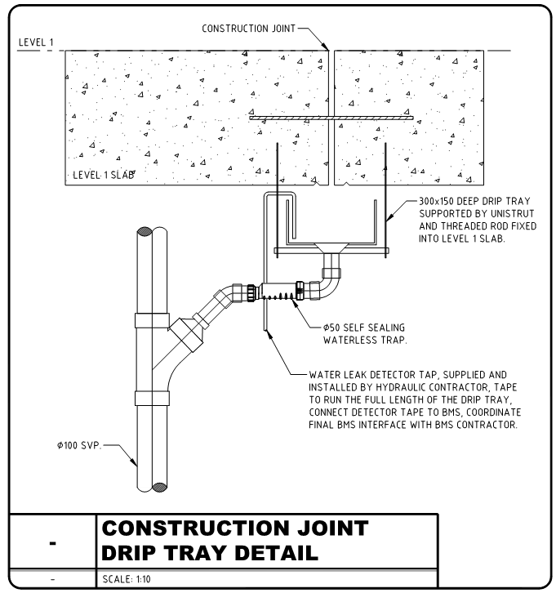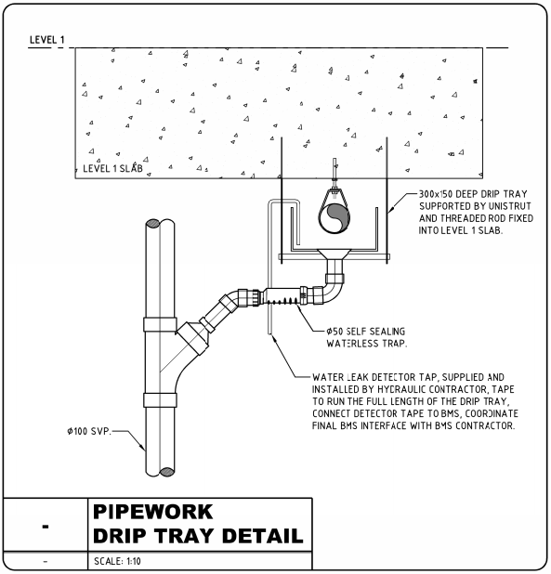
Detail 3A Detail 3B

- Services shall be arranged to ensure that access is always readily available for inspection and maintenance;
- The soil and waste pipes shall have acoustic lagging installed where required to conform to the requirements of the NCC;
- Test drains serving the buildings fire hydrant and or fire sprinkler system shall connect to the buildings sanitary drainage system. Each test drain shall be trapped with the trap charged by a solenoid timer valve.
- The geotechnical Assessment notes up 50-80mm of settlement to still occur, due to this extent of settlement the hydraulic drainage design needs to incorporate relevant measures to prevent damage to the drainage. The measures to protect the pipe work from fracturing is to introduce expansion sockets which will allow the entire drainage pipe work to settle with the soil without affecting the penetrations through the suspended groundfloor slab. Detail 3C provides a typical example of an expansion fitting.
- At each of the condensate tundish points serving the CRAC Units, mech equipment condensate and Fanwall units, to avoid excessive waste of water there is to be “grate seals” installed which also remove the risk of sewer gases becoming airborne within air conditioned rooms where trapped tundish water seals can be affected. Refer detail 3D as an example.
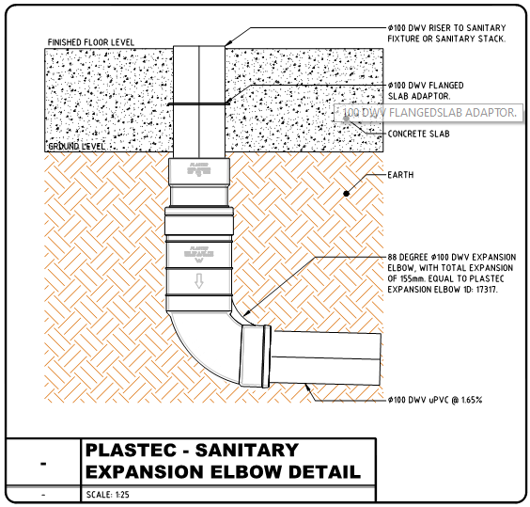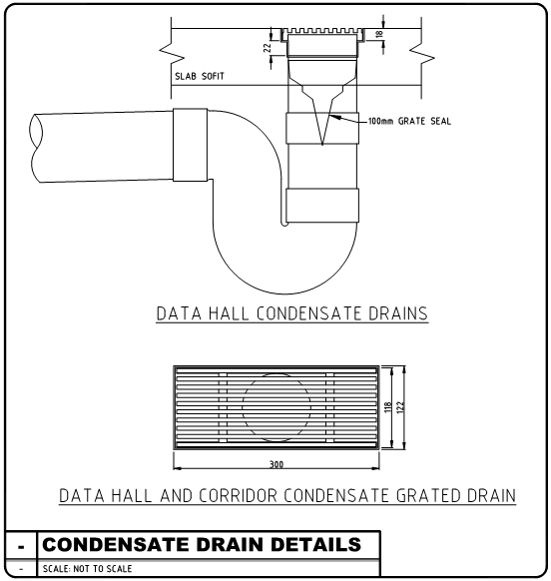
Detail 3C Detail 3D

- DOMESTIC COLD WATER
- The buildings main water meter assembly will be located on the ground floor within the Mechanical Plantroom and connected to the BMS;
- In order to comply with the requirements of AS3500.1 Water Services, the design is to incorporate pressure limiting valves (if required) to ensure that the water pressures is a maximum of 500kPa at all water outlets.
- All isolation valves are to be tagged and an isolation valve schedule is to be produced by the hydraulic contractor to list all valves by valve number and to identify the valves location and what fixtures the valve isolates.
- All cold water supply lines that are located in areas that are not air conditioned (eg open to atmosphere or under metal deck roof spaces) are to be insulated with flexible elastomeric closed-cell pipe installation (having spread of flame rating 0 and smoke developed rating 3 when tested against AS1530 Part 3 1989. The minimum thickness of the insulation is to be as follows:
Pipework Diameter Minimum Insulation thickness
15mm 13mm
20mm 19mm
32mm 25mm
40mm 32mm
The insulation is required to both satisfy the Australian Standards requirements and to reduce the risk of the supply lines freezing when the lines are not in use.
- Every fixture is to have individual isolation valves installed. The connection of the isolation valves to the fixture is to be via braided stainless-steel flexible lines;
- A capped 20mm-diameter provisional cold-water point and water meter is to be provided to serve each future leased space (where required). The provisional cold-water point and water meter is to be located within the ceiling space of the leased space in a position nominated by the client and the water meter is to be linked to the BMS.
- Non potable or Rainwater Reuse system shall have a potable water back up system, this system shall automatically change over in the event that the non-potable supply is not available (eg. rainwater tank is empty). As part of this system there shall be a backflow prevention device called an Reduced Pressure Zone Device or RPZD to prevent cross contamination of the non-potable water with the potable supply.

- DOMESTIC HOT WATER

- The hot water reticulation system shall be designed in accordance with the relevant codes and Australian Standard;
- Where required hot/tepid water pipes shall be insulated with flexible elastomeric closed-cell pipe installation (having spread of flame rating 0 and smoke developed rating 3 when tested against AS1530 Part 3 1989). The minimum thickness of the insulation is to be as follows:
Pipework Diameter Minimum Insulation thickness
15mm 13mm
20mm 19mm
32mm 25mm
40mm 32mm
- The domestic centralized electric instantaneous hot water heaters will be located in the ceiling space above wet areas and amenities, access to the units will be via a minimum 600 x 600 access panel;
- Disabled and Cleaners rooms will be served via a factory set Electric instantaneous electric hot water heater with 60°C hot water to feed directly to the cleaners sink hot water tap and to the Disabled amenities Thermostatic mixing valve that will mix the hot water with the incoming cold water to a max temp of 43°C which will then fee the disabled amenities basin and shower.
- Thermostatic mixing valves shall be located within the disabled amenities, recessed within the wall using a stainless-steel lockable cabinet.
- Staff Amenities and Visitors Amenities will be served via a factory set Electric instantaneous electric hot water heater with 50°C hot water to feed directly to basins and showers.
- The proposed maximum length of hot/tepid water from the Instantaneous Electric Hot Water Heater to the furthest outlet is to be limited to 15m;
- Every fixture is to have individual isolation valves installed. The connection of the isolation valves to the fixture is to be via braided stainless-steel flexible lines;
- Hot water provision is not required in the Staff Breakouts/Kitchenettes as these spaces will be serviced via under sink ZIP 4 in 1 units;

- ROOFING, GUTTERS AND DOWNPIPES

- All roof stormwater collection to allow adequate draining during a storm event with a rainfall intensity of:
- 262mm/hr for a 5 minute period for box gutters; and
- 200mm/hr for a 5 minute period for eaves gutters.
- Roof stormwater is to include for all downpipes for roof drainage, and connection to the stormwater drainage system;
- Downpipes shall be external to the building and terminate above a downpipe sumps;
- Eaves gutters are to be installed with continual overflow provision and shall be installed in accordance with AS3500.3.
- Where box gutters are installed, overflows shall be provided through the parapet of at least equal capacity to the downpipes to prevent accidental flooding;
- STORMWATER DRAINAGE
- Each downpipe sump will connect via gravity drainage to the nearest Civil stormwater sump. In some instances where it is more cost effect several downpipe sumps will have their drainage linked together and then extend to the nearest Civil stormwater sump as required.
- A portion of the roof will be captured by the buildings inground rainwater tank for reuse as part of toilet flushing, mechanical supply water to the humidifiers and where required charging trapped tundish points and fire service test drains.
- The buildings rainwater tank will be designed in accordance with Blacktown City Council requirements by the projects Civil Engineer.
- The rainwater reuse pump set will be located above ground within the Mechanical Plantroom, part of the rain water reuse system will include a filtration system comprising of a automatic back wash filter, mirco filter and Ultra Violet disinfection.

- FIRE HYDRANT AND FIRE HOSE REEL SYSTEMS

- A fire hydrant system shall be provided to serve the development in accordance with the NCC, SAA Code for Installation of Fire Hydrants - AS2419, the NSWFB requirements and any ‘Alternative Fire Engineered Solution’ approved by the Local Fire Brigade – This will be provided by the prjects Fire Servies Engineer.
- A fire hose reel system shall be provided (unless removed via an Alternative Solution) to serve the development in accordance with the NCC, SAA Code for Installation of Fire Hose Reels - AS2441, the NSWFB requirements and any ‘Alternative Fire Engineered Solution’ approved by the Local Fire Brigade;
- Hydrant and Sprinkler test drains shall connect to the buildings sanitary drainage system.

- METERING

As a guide below is the proposed metering arrangement;
- Main site domestic cold water meter;
- Cold water supply to the mechanical hot water plant;
Also refer to the Hydraulic Specification for a more detailed explanation of meter locations.
- FIXTURES AND FITTINGS

The fixtures are to have the following rating in accordance with AS/NZS 6400:2005 (as amended):
- Showers to have a 3 star rating based on a flow rate of more than 7.5 litres/minute but not more than 9.0 litres/minute;
- Sink taps to have a 4 star rating based on a flow rate of more than 6.0 litres/minute but not more than 7.5 litres/minute;
- Basin taps to have a 6 star rating based on a flow rate of not more than 4.5 litres/minute; and
- Toilets to have a 4 star rating based on an average flush volume of more than 3.0 litres but not more than 3.5 litres/minute. This is based on using 4.5/3 litre full/half flush toilets;
- Kitchenettes and Breakout sinks will have a ZIP 4 in 1 undersink boiling/chilled/ambient/hot water unit to provide point of use hot water to the sinks flick mixer and to provide boiling/chilled water to ZIP hydro tap sitting over a separate font unit.

