Document: ICON Water,
Guideline 19 Response for a Brewery

Status For Information

For the Attention of: Client Company Name

Project Details: Sellick Job Number
Block XX, Section XX, Suburb ACT
Development Name

Prepared
Author: Carl Sommerville

Signature: (Original signed)

Date: 13 August 2020

Reviewed
Reviewer: Brad Williams

Signature: (Original signed)

Date: 13th August 2020

Revision | Date | Description of Revision | Prepared | Reviewed
01 | DD/MM/YYYY | For Information | CRS | BW

Contents
Contents 2
INTRODUCTION 3
1.0 SIGNED APPLICATION FORM (signature of the owner or a person who has the consent of the owner) 4
2.0 DRAINAGE DIAGRAMS AND PLANS OF SITE 4
3.0 TYPE OF PROCESS/ACTIVITY GENERATING THE LIQUID TRADE WASTE 4
4.0 CHEMICALS TO BE USED – SUPPLY MSDS 4
5.0 QUANTITY AND RATE OF DISCHARGE 4
6.0 LIKELY SUBSTANCES IN WASTE STREAMS INTENDED FOR DISCHARGE TO SEWERAGE SYSTEM 4
7.0 DETAILS OF PROPOSED PRE-TREATMENT EQUIPMENT INCLUDING OTHER INSTRUMENTATION REQUIREMENTS 4
8.0 MAINTENANCE SCHEDULE FOR PRE-TREATMENT EQUIPMENT, INCLUDING ALL PITS, PUMPS ETC./DETAILS OF MAINTENANCE PERSONNEL 5
9.0 EXPECTED QUALITY AFTER PRE-TREATMENT – (Sample Data, guaranteed by equipment supplier or recommended by Consultant) 5
10.0 MEASURES FOR PREVENTION OF STORMWATER INGRESS TO THE SEWERAGE SYSTEM 5
11.0 CHEMICAL HANDLING AND STORAGE FACILITIES (Where Necessary) 5
12.0 WASTE DISPOSAL MANAGEMENT (Other than sewer) 5
13.0 APPLICANTS CONTACT DETAILS 5
APPENDIX A – PHOTOS FROM SITE INSPECTION 6
APPENDIX B – FLOOR PLAN 9
APPENDIX C - MSDS 10

INTRODUCTION

Tortured Gum Brewery is a local company (formally known as You Brew it) who offer Brew on premises to the general public using commercial grade brewing equipment.

The current owner took over the company in 2013 (changing the name of the business at the same time) and as part of a recent ICON Water Trade Waste Department audit, the owner needs to provide a new Non-Domestic Discharge to Sewer Application in accordance with Acceptance Guideline 20 – High risk discharges.

Sellick Consultants have been engaged by the business owner to compile and submit the new Non-Domestic discharge to sewer application.

- SIGNED APPLICATION FORM (signature of the owner or a person who has the consent of the owner)
Attached Separately.
- DRAINAGE DIAGRAMS AND PLANS OF SITE
Attached Separately
- TYPE OF PROCESS/ACTIVITY GENERATING THE LIQUID TRADE WASTE
On Premises brewing of beer by the general public for private consumption, small batches (50L), with some small commercial brewing is conducted using the same small batch equipment as the general public.
- CHEMICALS TO BE USED – SUPPLY MSDS
Refer attached MSDS for reference, Appendix B
- QUANTITY AND RATE OF DISCHARGE
- Under normal operation, rise water from cleaning of the kettles (65 degrees @ less than 0.5L/s) for 1 – 2 minutes per kettle. End of day cleaning of kettles with AVOID (10ml/50L @ 40-60 degrees) approx. 2L per kettle and sanitising with MANDATE PLUS (1.3mL/1L @ 15-25 degrees) 2L per kettle.
- Rinse water for bottles (15-25 degrees @ less than 0.5L/s) for 1 – 2 minutes. Sanitising of bottles using Mandate Plus (1.3mL/1L @ 15-25 degrees for 30 seconds) in a closed loop system.
- iii. Cleaning of kegs using Avoid (10ml/50L @ 40-60 degrees for 2 minutes) in a closed loop system. Total discharge per batch 50L at 1L/s when rinsing kegs up to 1 minute.
- iv. Cleaning of beer filters (back flush) up to 4 times a week using Ultrasil 25 (50ml/10L) 15L per wash.
- v. Cleaning of floors using Top Cellar Cleaner – Sanitiser (25ml/1L), daily mopping approx. 10L-20L per day.
- vi. Sanitising of closed loop systems and pipelines using Mandate Plus (1.3mL/1L) up to 4 times a week 20-30L per wash.
- vii. Monthly cleaning of kettles using Stonekleen (100ml per 10L @ 40-60 degrees) approx. 25L for all kettles.
- LIKELY SUBSTANCES IN WASTE STREAMS INTENDED FOR DISCHARGE TO SEWERAGE SYSTEM
Refer item 5.0 responses above.
- DETAILS OF PROPOSED PRE-TREATMENT EQUIPMENT INCLUDING OTHER INSTRUMENTATION REQUIREMENTS
- Downstream drain at kettle trough has a bucket trap installed with filter sock for capturing malt/barley residue.
- Bucket trap installed at the keg wash.

- MAINTENANCE SCHEDULE FOR PRE-TREATMENT EQUIPMENT, INCLUDING ALL PITS, PUMPS ETC./DETAILS OF MAINTENANCE PERSONNEL
- Bucket traps emptied daily into a waste receptacle.
- Waste receptacles emptied into hoppers located in existing shared waste enclosure.
- EXPECTED QUALITY AFTER PRE-TREATMENT – (Sample Data, guaranteed by equipment supplier or recommended by Consultant)
Quality of discharge falls within the General Acceptance Criteria for Liquid Trade Waste.
Refer MSDS for further dilution rates.
- MEASURES FOR PREVENTION OF STORMWATER INGRESS TO THE SEWERAGE SYSTEM
All bucket traps, floor waste are located internal of the building structure where there is no stormwater ingress.
The existing waste enclosure is roofed and bunded as required to prevent stormwater ingress into the sewer network.
- CHEMICAL HANDLING AND STORAGE FACILITIES (Where Necessary)
Chemicals stored out of reach of general public in small volumes.
- WASTE DISPOSAL MANAGEMENT (Other than sewer)
Not applicable to this project
- APPLICANTS CONTACT DETAILS

Sellick Consultants:
Carl Sommerville
02 6201 0200

Tortured Gums Brewery
Craig McAuliffe
0402 837 796
craig@torturedgum.com

APPENDIX A – PHOTOS FROM SITE INSPECTION
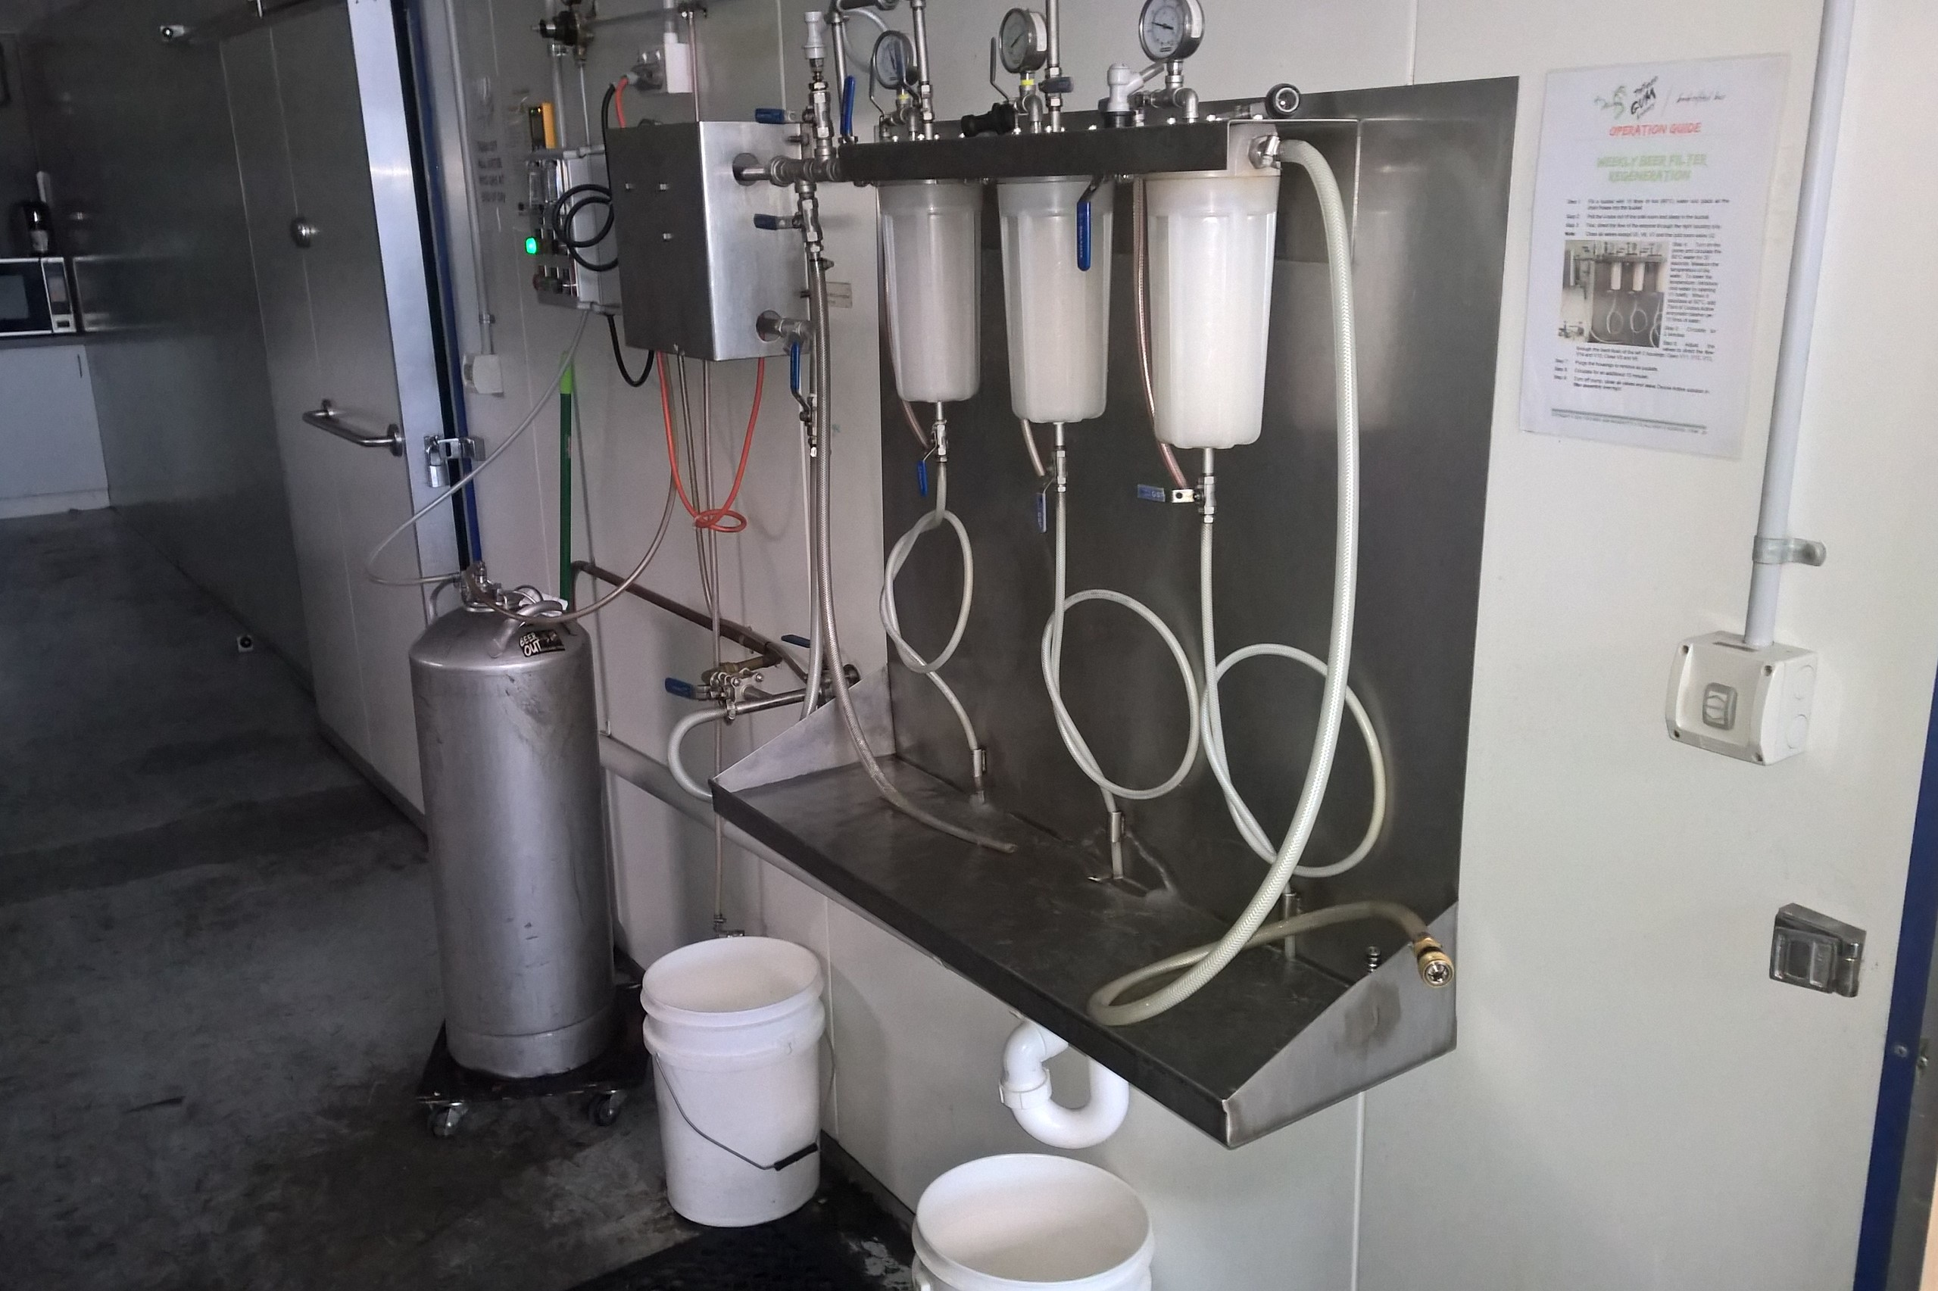
Beer Filters

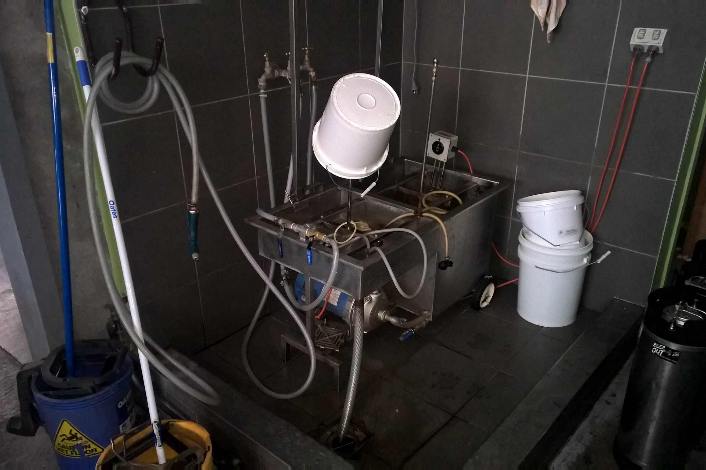
Keg Wash/Sanitiser (with bucket trap)
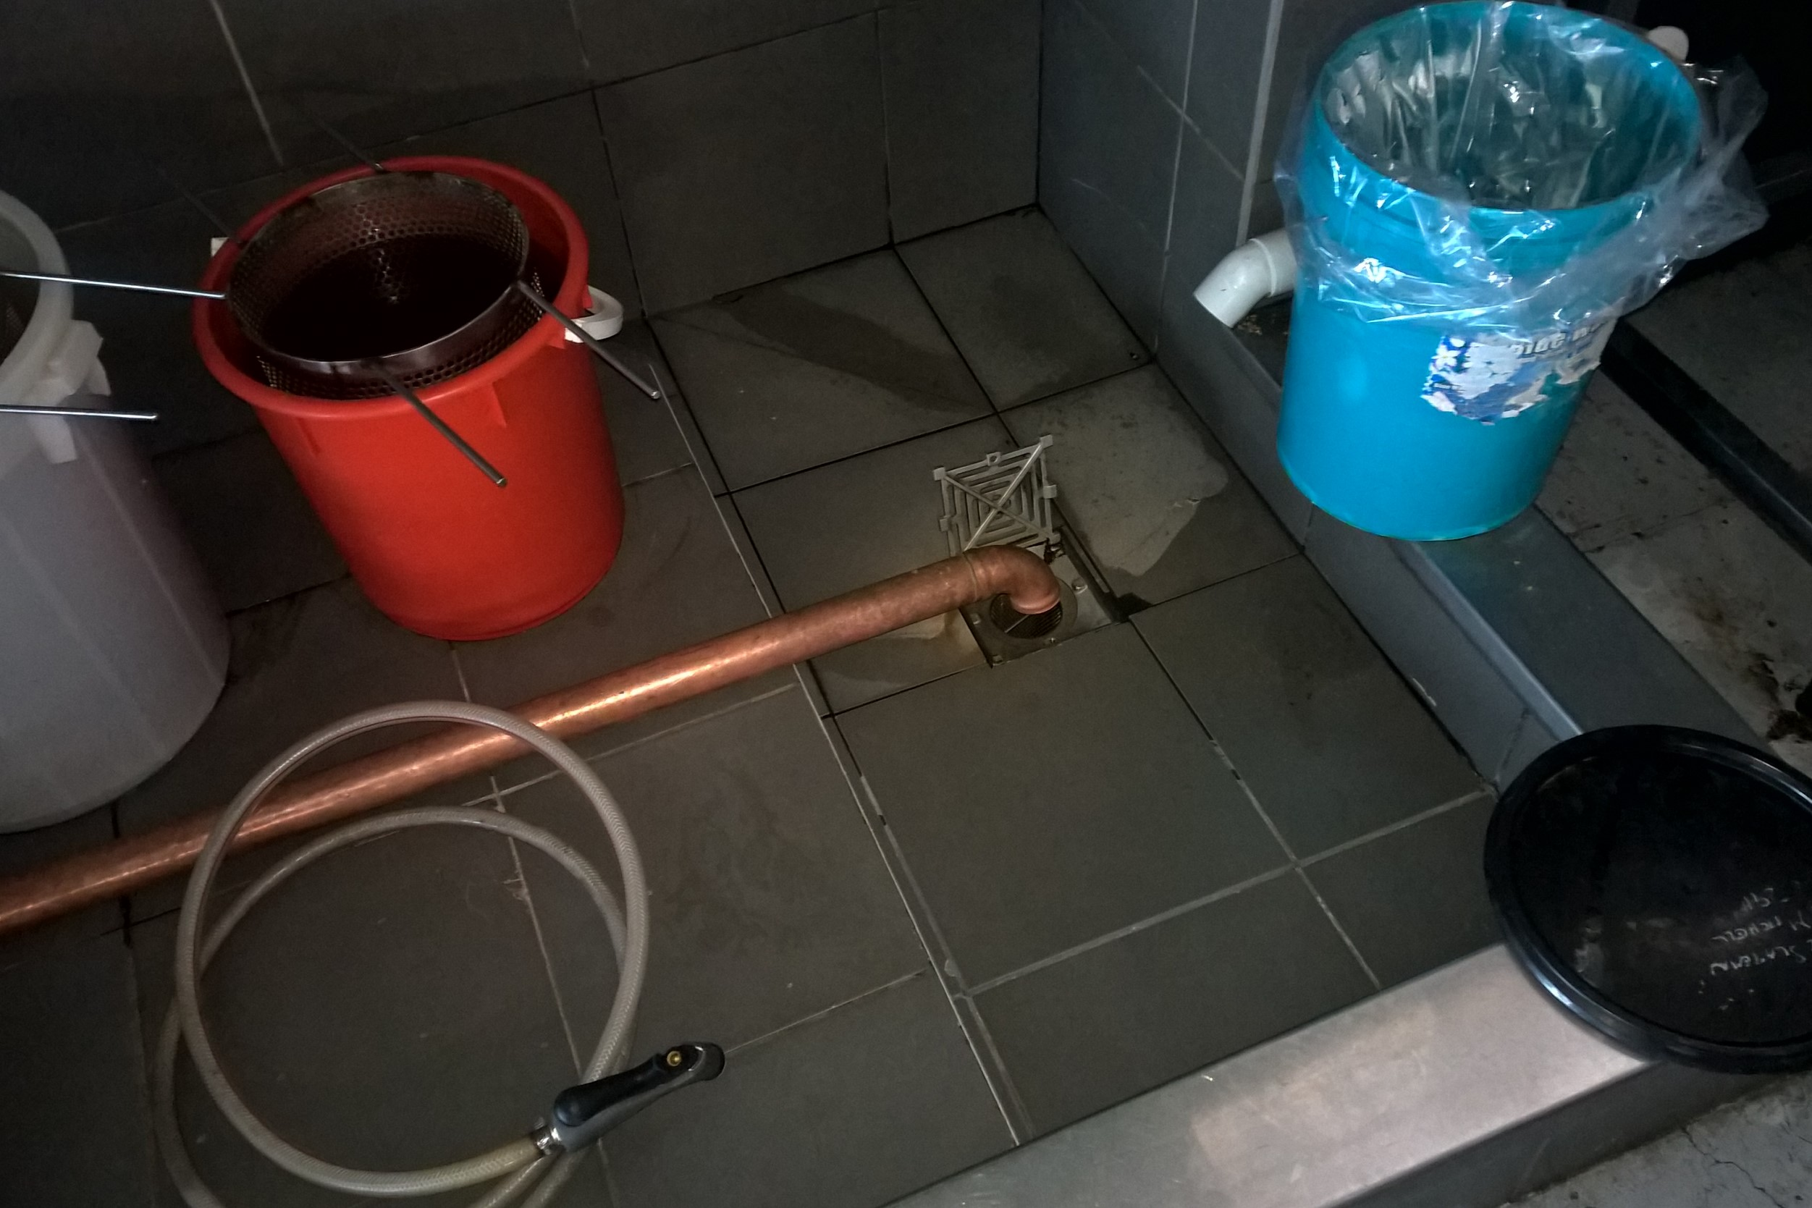
Kettle Trough drain (bucket trap)

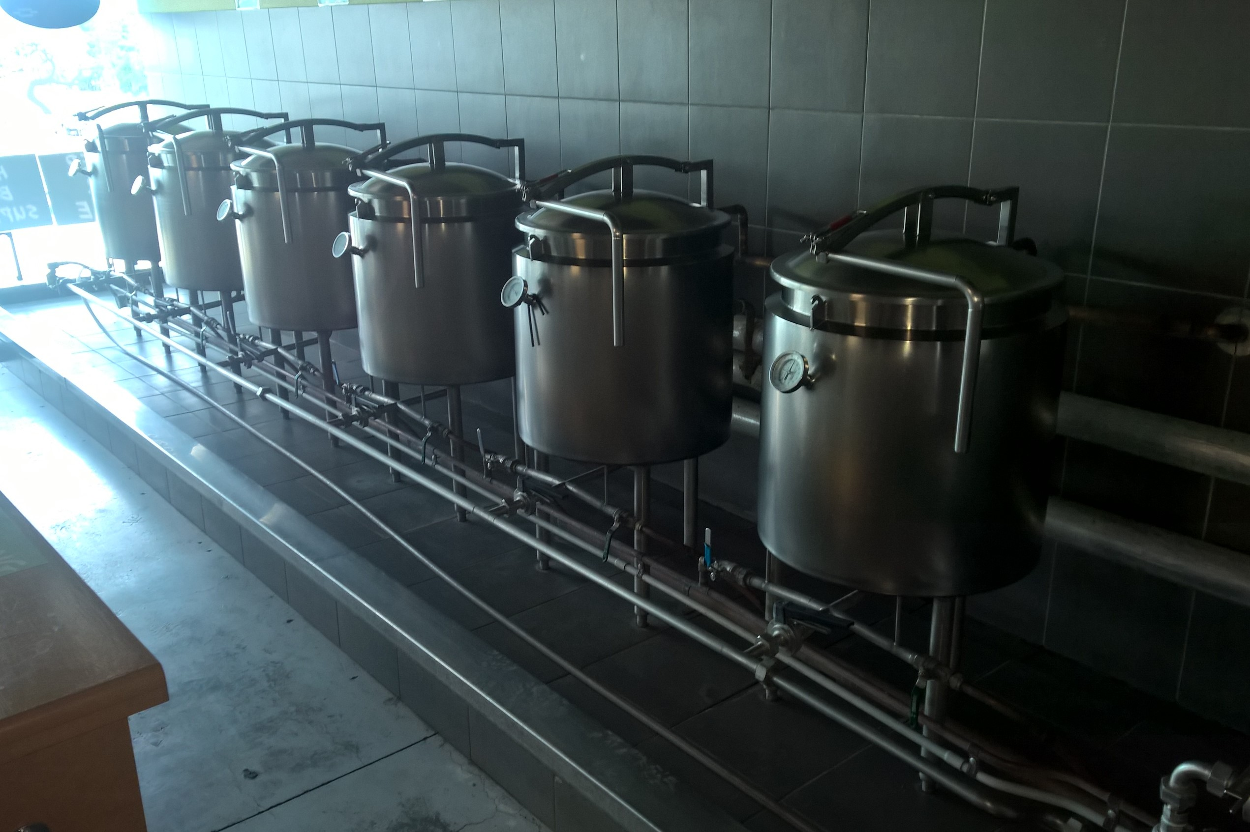
6 x 50L brewing kettles (located in tiled trough)

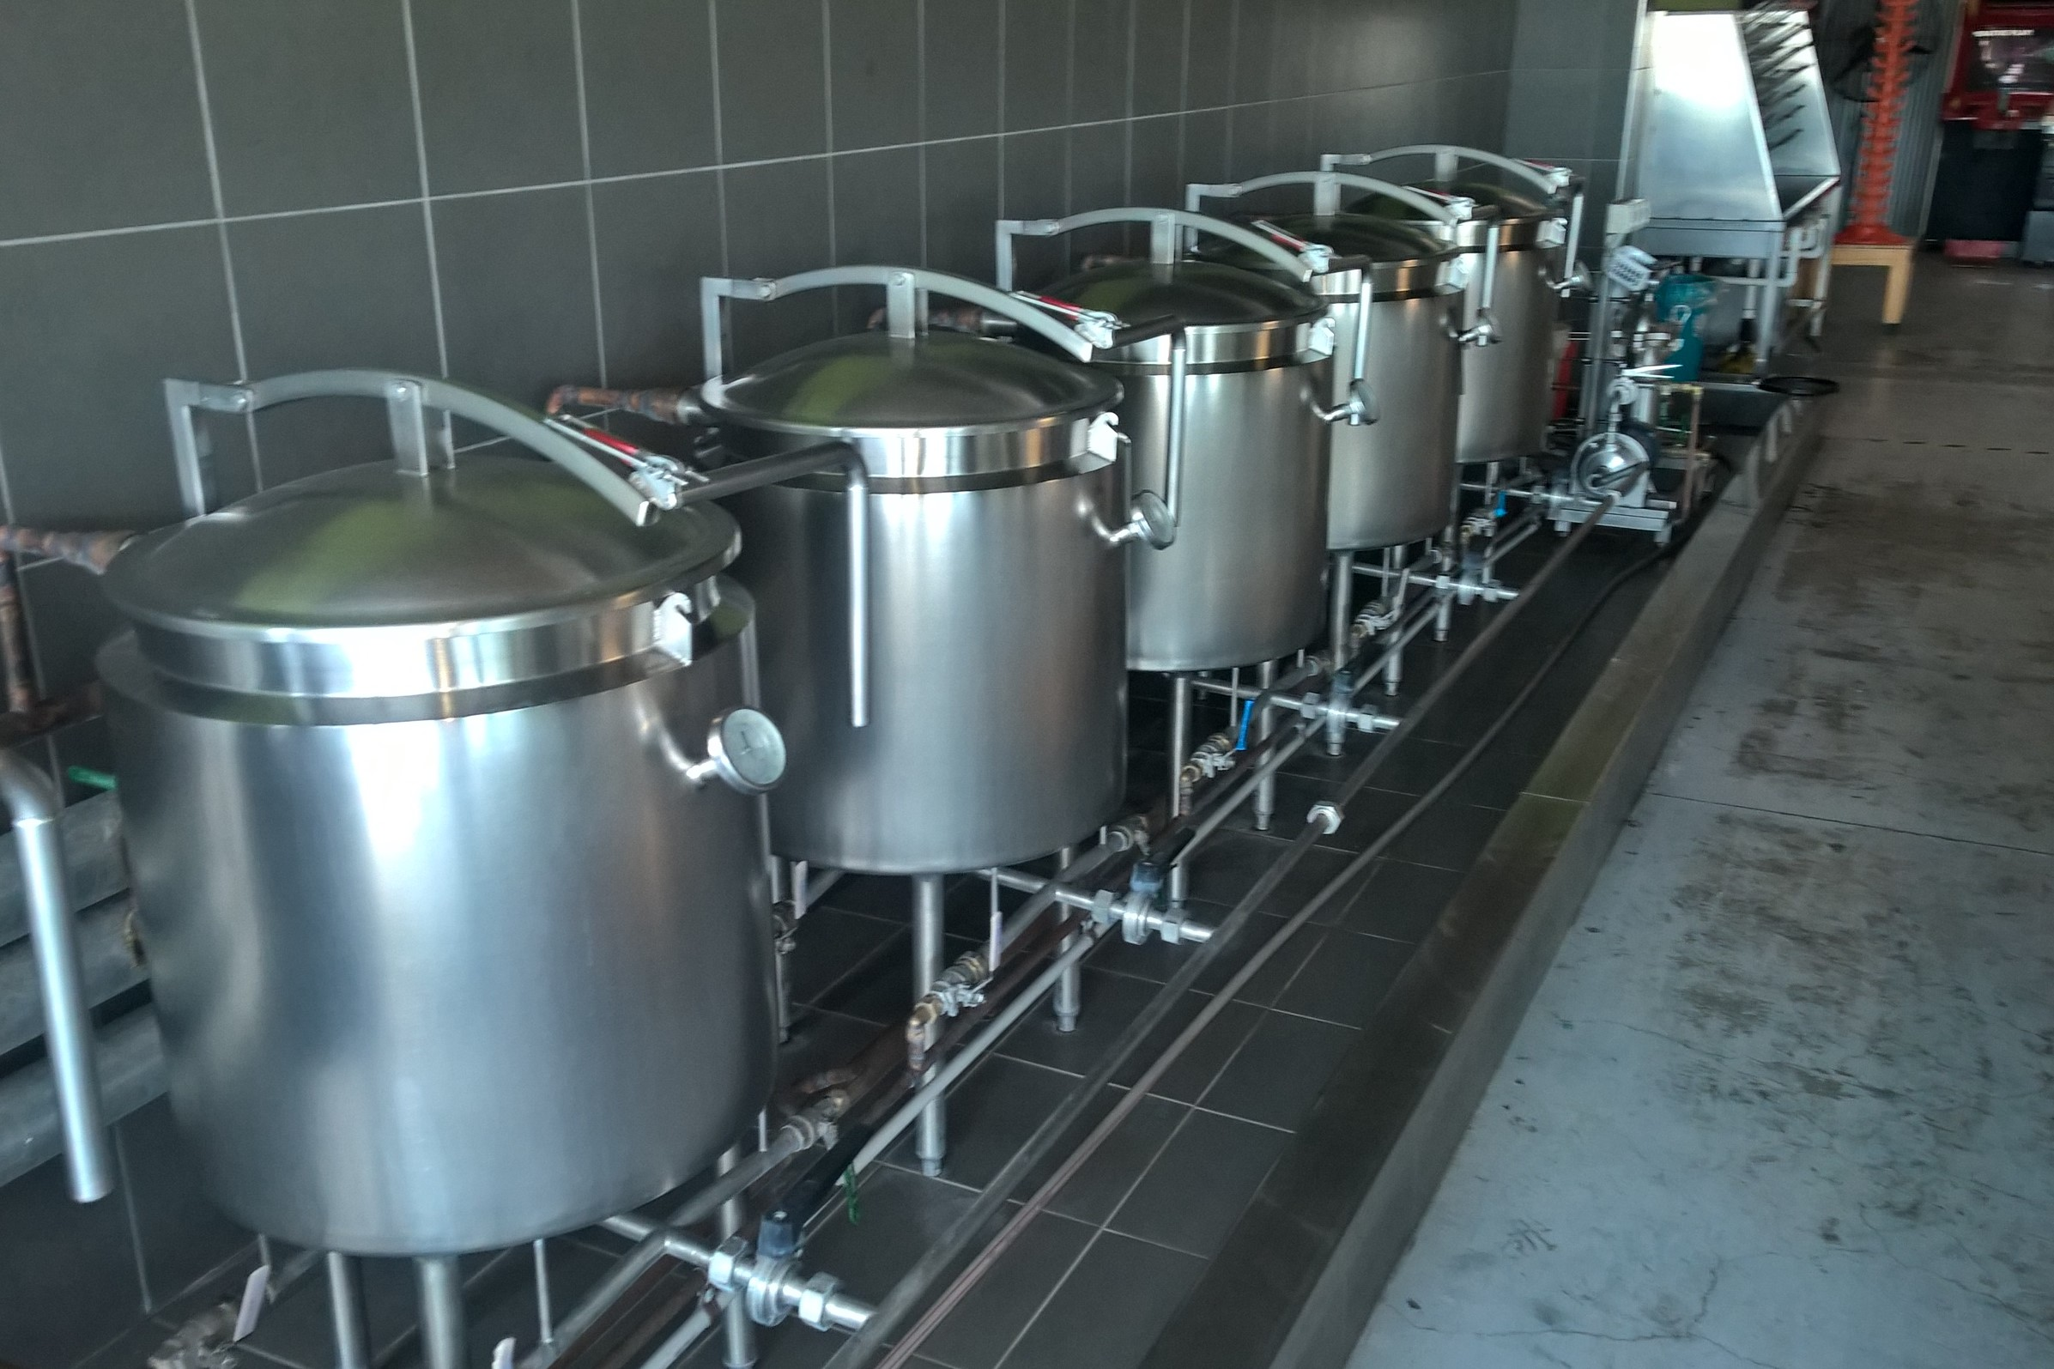
Brewing kettles looking back toward the trough drain

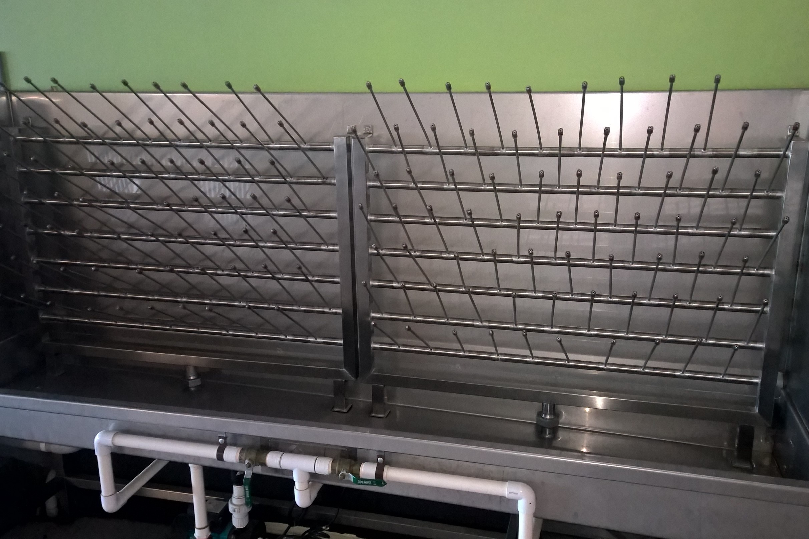
Bottle sanitiser station

APPENDIX B – FLOOR PLAN

APPENDIX C - MSDS

